ASSIGNMNT 2

1. Identify the error in program Program:

#include<iostream> void main()

{

int i=0; i=i+1;

cout<<i<<" "; cout<<i;

}

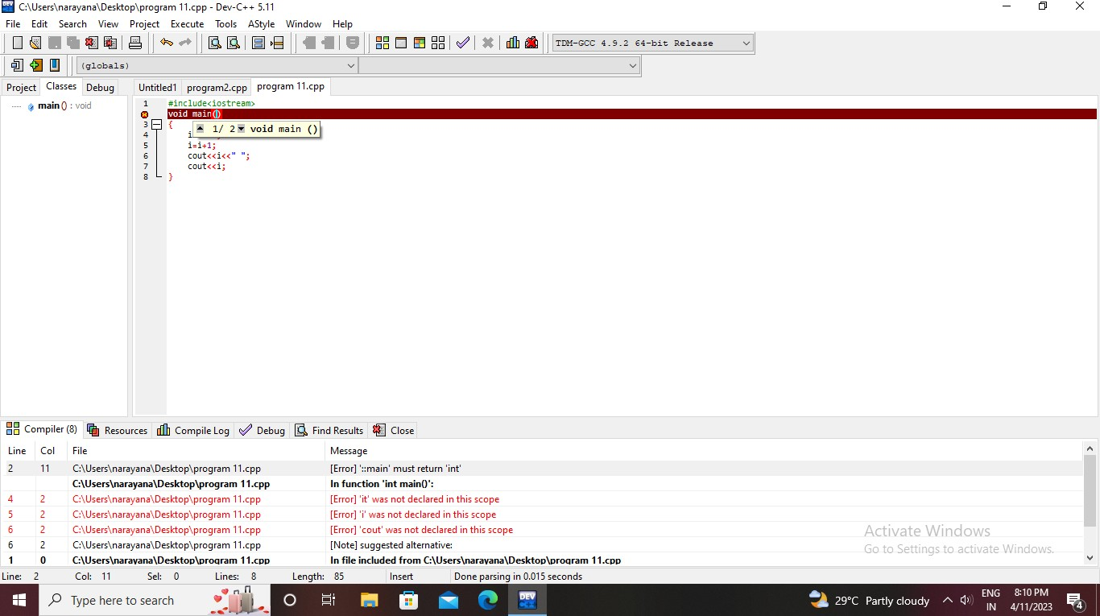Output:

1. Identify the error Program:

#include<iostream.h> void main()

{

short i=2500, j=3000; cout>>" i+j ">>=(i+j);

}

Output:

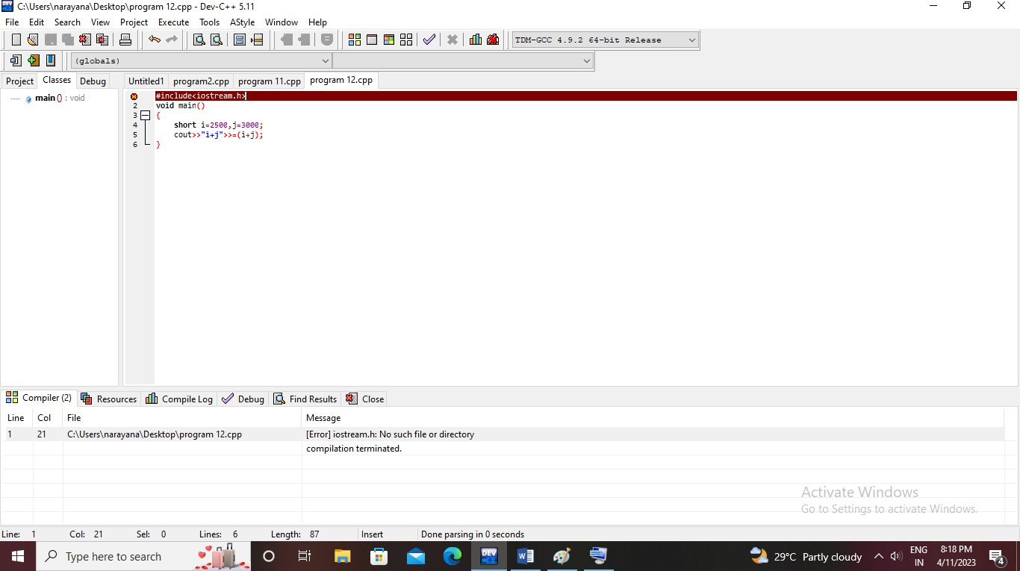

3. will happen when you run following program Program:

#include<iostream.h> void main()

{

int i=10, j=5;

int modresult=0; int divresult=0; modresult=i%j; cout<<modresult;

divresult=i/modresult; cout<<divresult;

}

using namespace std; #include<iostream> int main()

{

int i=10, j=5;

int modresult=0; int divresult=0; modresult=i%j; cout<<modresult;

divresult=i/modresult; cout<<divresult; return 0;

}

Output:

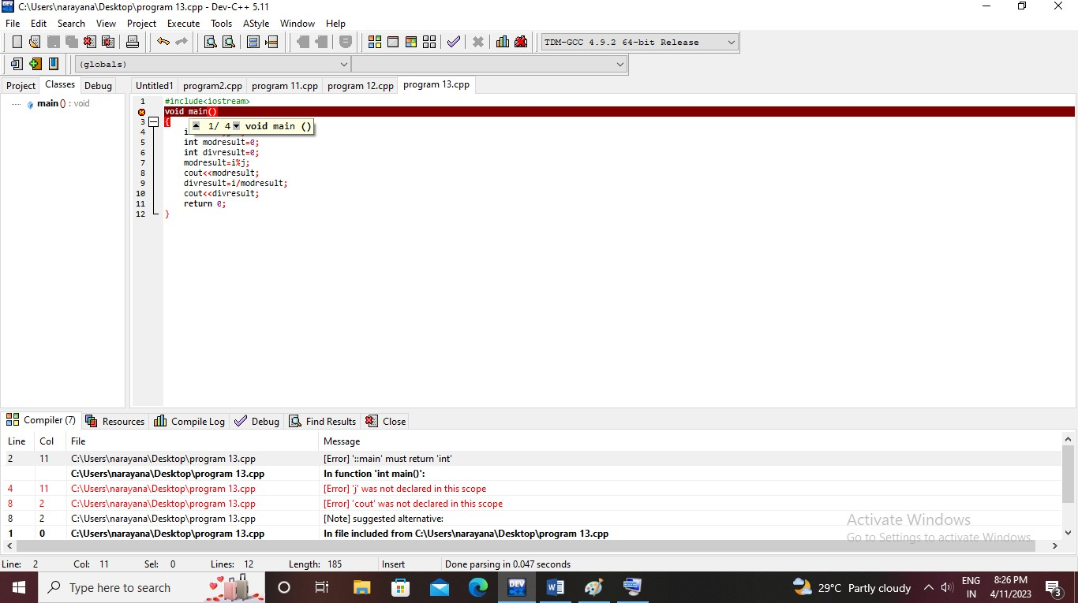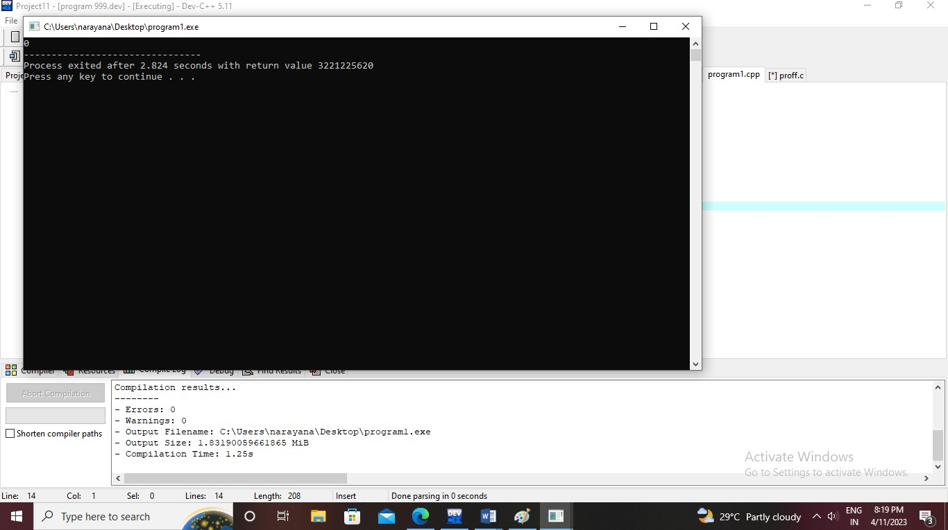

1. What happens if the following program is executed in C and C++?

Program :

#include <stdio.h> int main(void)

{

const int j = 20; int *ptr = &j;

printf("*ptr: %d\n", *ptr); return 0;

}

using namespace std; #include<iostream> int main(void)

{

int j = 20; int *ptr = &j;

cout<<(*ptr); return 0;

}

Output:

In c:

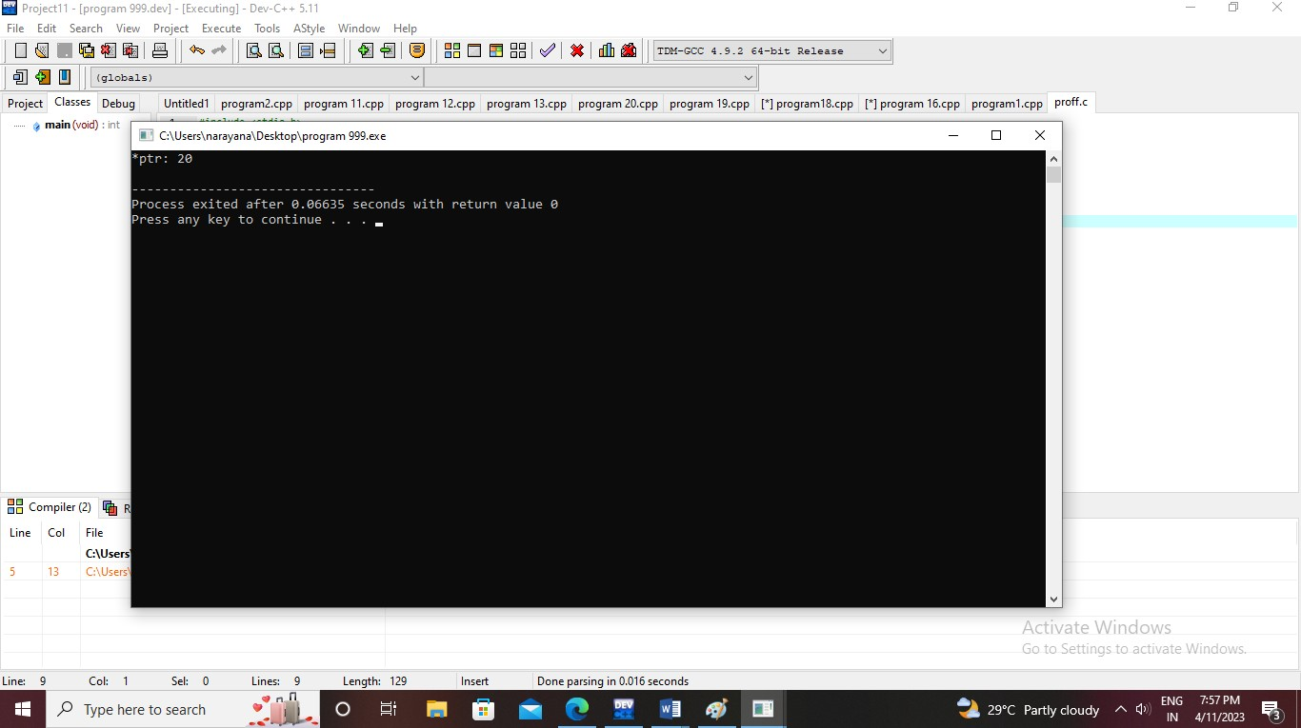

In c++:

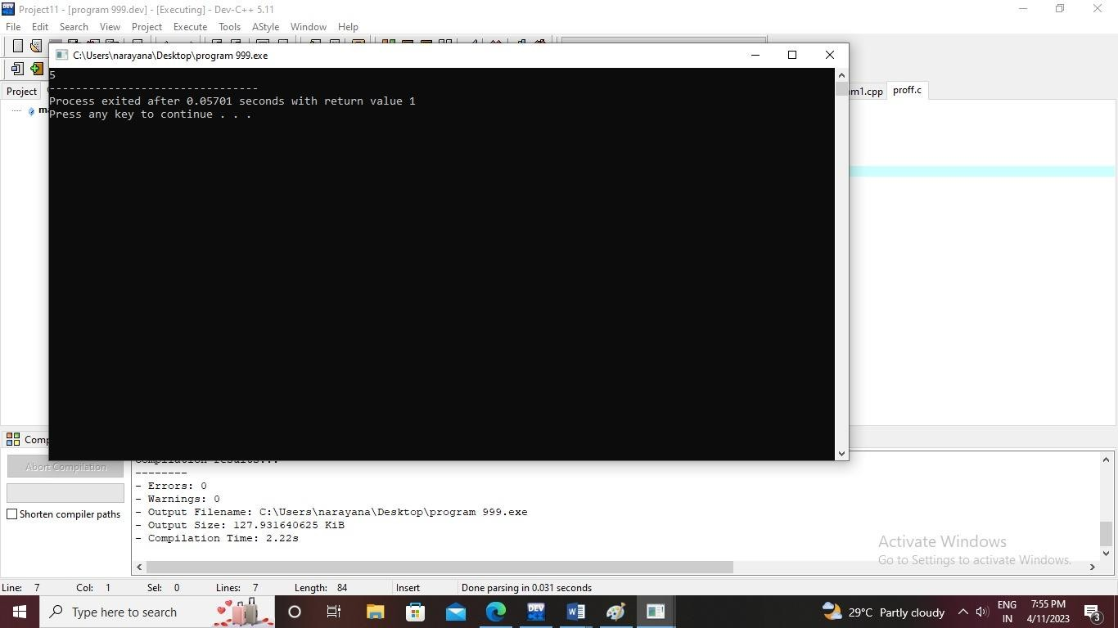

1. What happens if the following program is executed in C and C++?

#include <stdio.h> int main(void)

{

int new = 5; printf("%d", new);

}

In c:

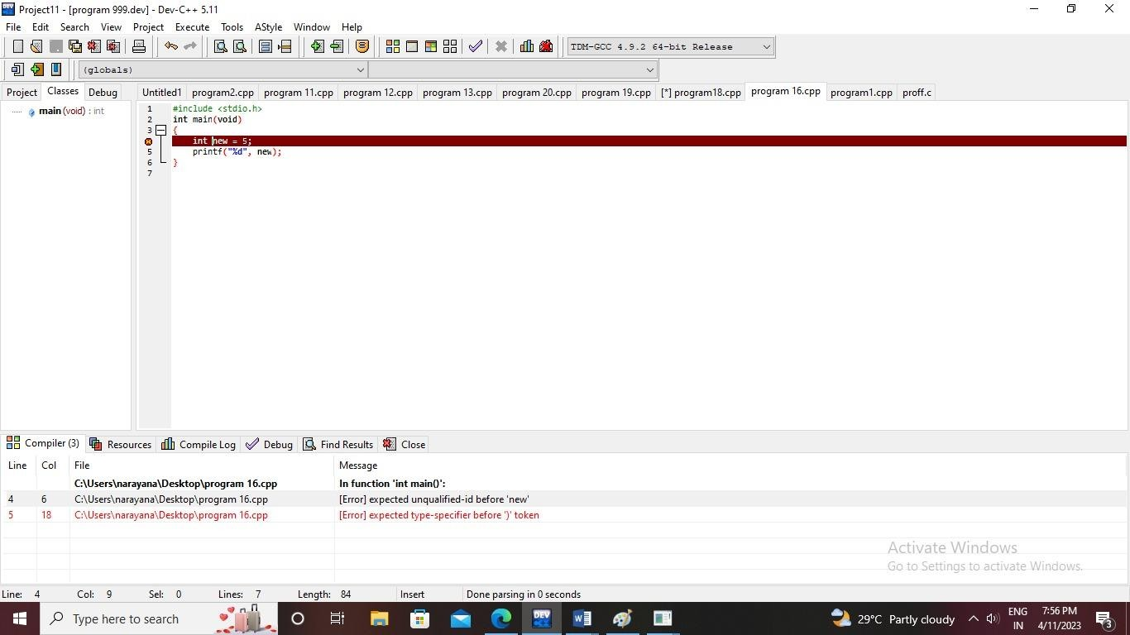

In c++:

Write c++ program for finding Square root of number. #include<iostream>

#include<math.h> using namespace std; int main()

{

float sq,n;

cout<<"Enter any positive number :: "; cin>>n;

sq=sqrt(n);

cout<<"\nSquare root of Entered Number is :: "<<sq<<endl; return 0;

}Output:

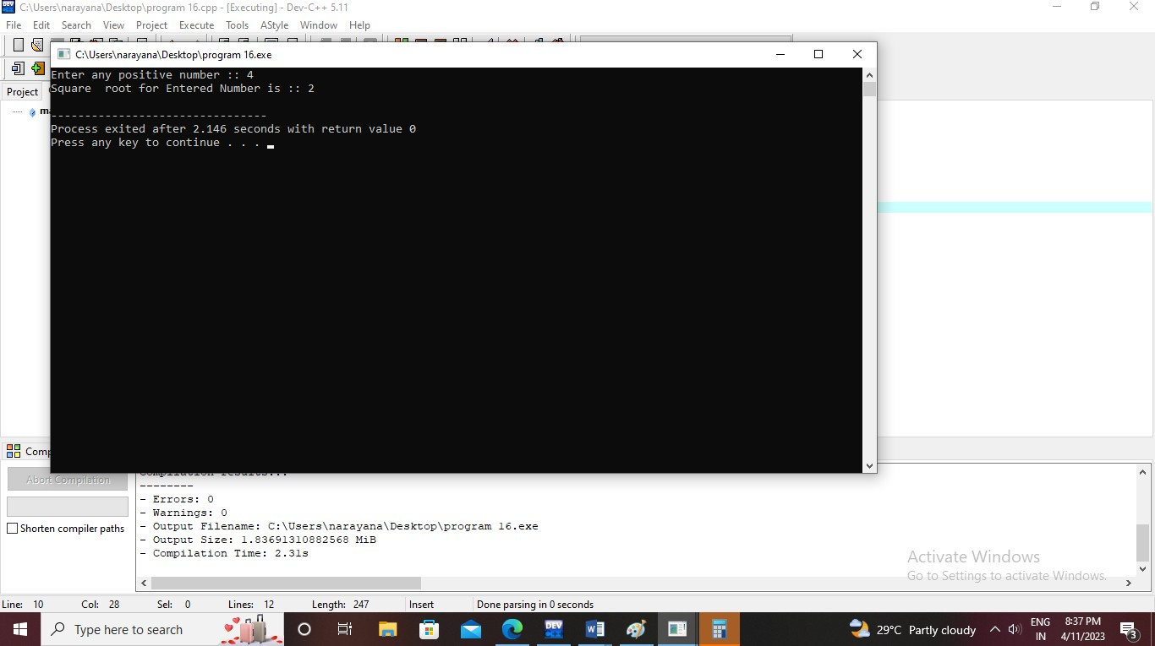

A person wants to find his birthday day, but he has known no of days present only.

Find the no of days, no of years and no of weeks present for his birthday. Input:

#include<iostream> using namespace std;

#define DAYS_IN_WEEK 7 void find(int number_of_days)

{

int year, week, days;

year = number_of_days / 365;

week = (number_of_days % 365) / DAYS_IN_WEEK; days = (number_of_days % 365) % DAYS_IN_WEEK;

cout << "years = " << year; cout << "\nweeks = " << week;

cout << "\ndays = " << days;

}

int main()

{

int number_of_days = 400; find(number_of_days);

return 0;

}

Output:

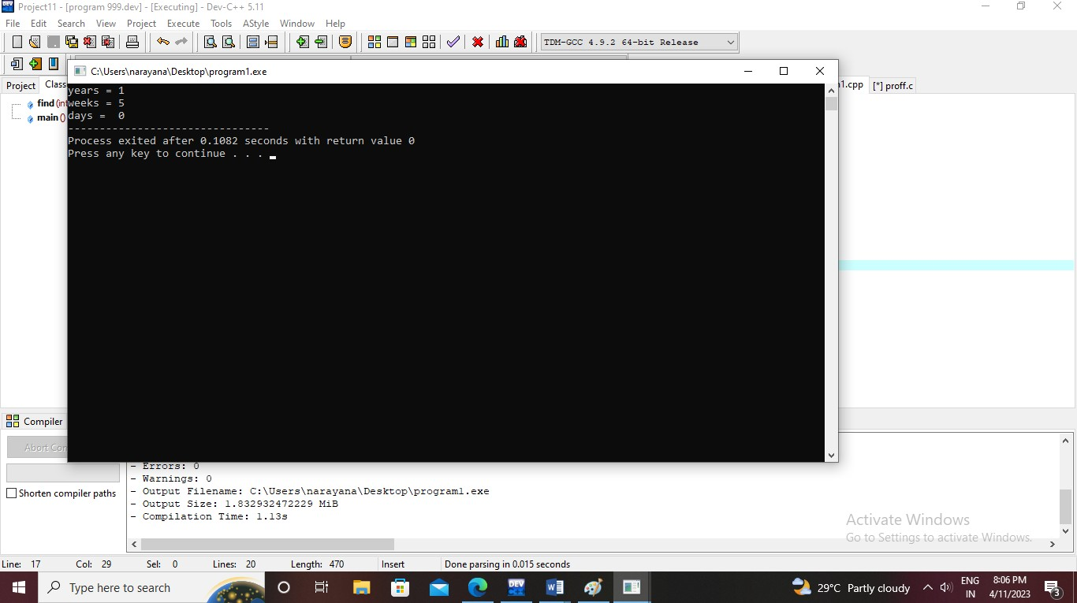

A person wants to invest amount in financial institution and he wants find the compounded interest he will get, if no of year 385000, roi is 13.89 and time period is 4.

Write the code for above scenario. #include<iostream> #include<math.h>

using namespace std; int main(){

float p,r,h,t; cout<<"enter principle"; cin>>p;

cout<<"enter time"<<endl; cin>>t;

cout<<"enter rate"<<endl; cin>>r; h=p*pow((1+r/100),t);

cout<<"calculated interest:"<<h<<endl;

}

Output:

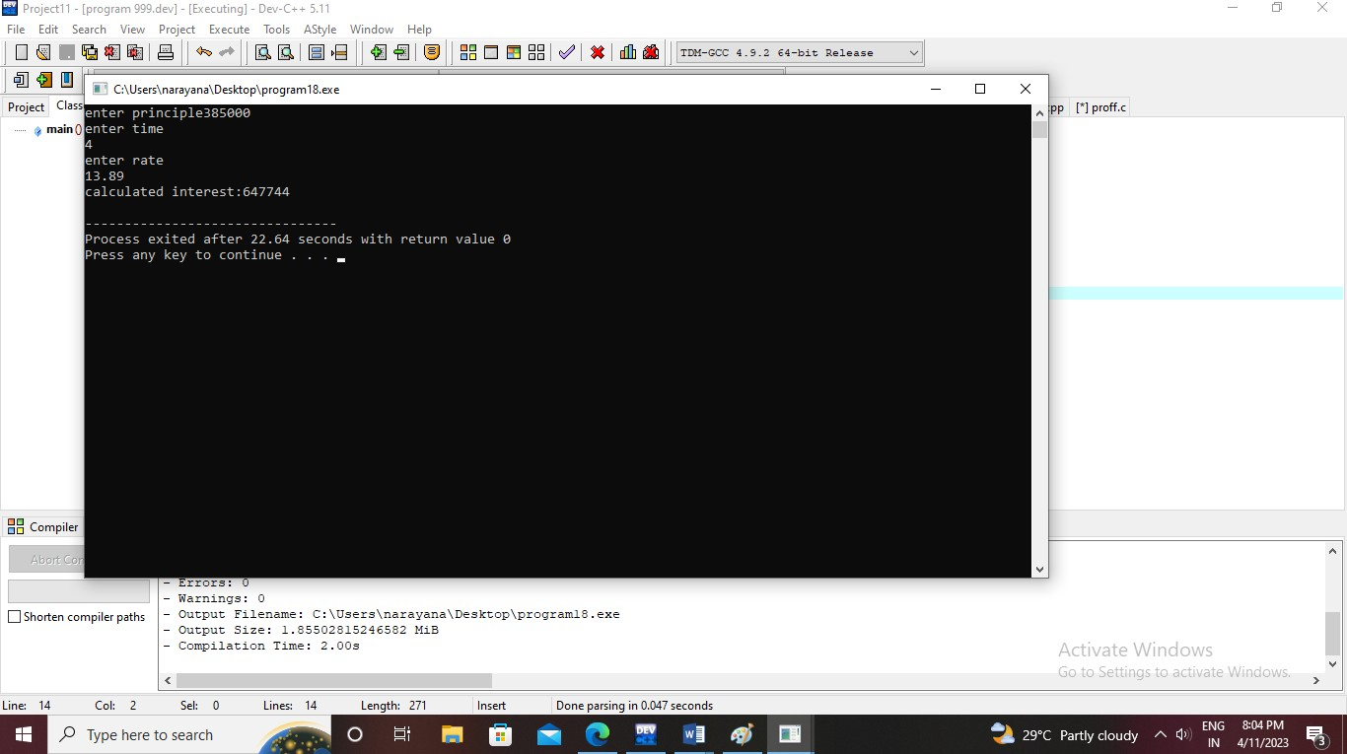

C++ Program to Check Character is Uppercase, Lowercase, Digit or Special #include<iostream>

using namespace std;

int main(){

int a;

cout<<"enter your favourite character or digit"; cin>>a;

if(a>=65 and a<=90){

cout<<"you enter the uppercase value"<<endl;

}

else if(a>48 and a<=57){

cout<<"you enter an digit"<<endl;

}

else if(a>=97 and a>=122){

cout<<"you enter an lowercase"<<endl;

}

else{

}

}

Output:

cout<<"you enter an speial character"<<endl;

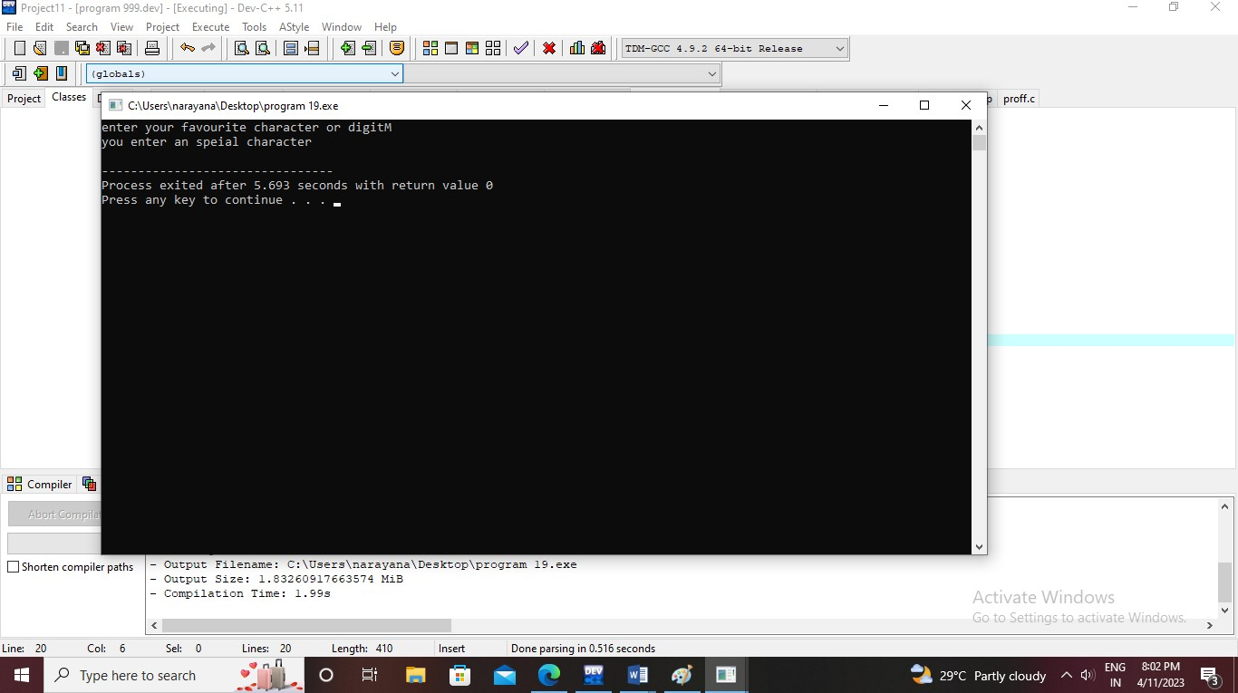

Write a program to display ascii value of character. #include<iostream>

using namespace std;

int main(){

char a;

cout<<"enter the alphabet to change to ASCI code"; cin>>a;

cout<<"the value in ASCI code:"<<int(a)<<endl; return 0;

}

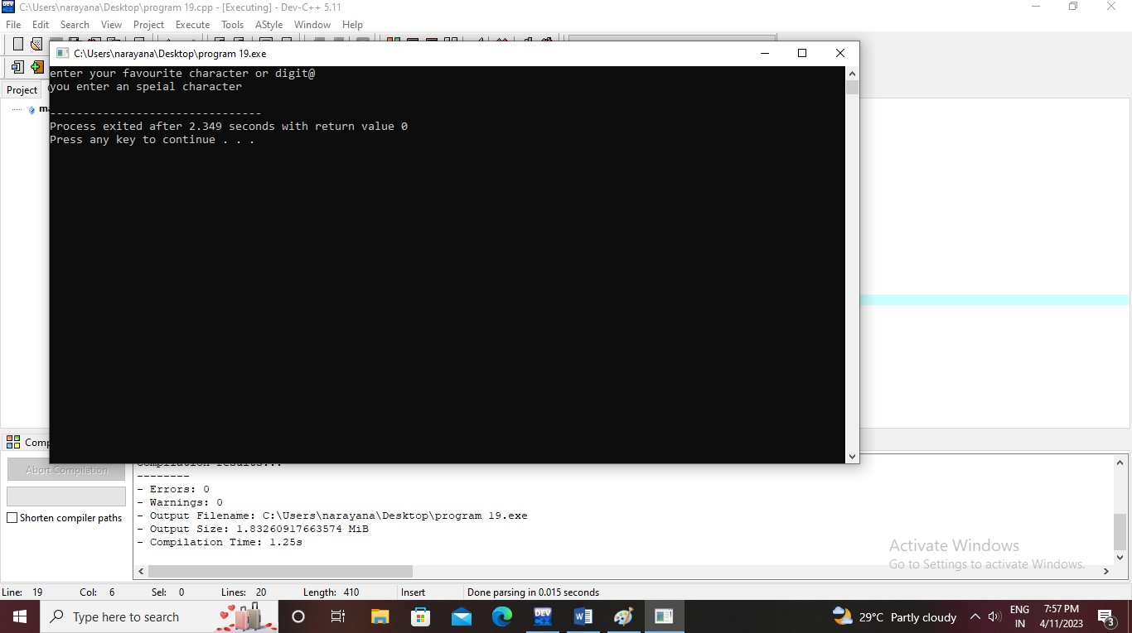Output: